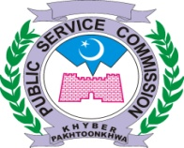

KHYBER PAKHTUNKHWA PUBLIC SERVICE COMMISSION

SUBJECT: POSTPONEMENT OF INTERVIEWS IN THE MONTH OF JULY, 2024:

The Hon’ble Chairman PSC is pleased to postponed interviews for the posts of Senior Research Officer (BPS-18) in Agriculture Department (Advt. 01/2022 sr. 03) fixed with panel-III on 11th and 12th July, 2024.
All interviews fixed on 15th July, 2024 will also be postponed due to Muharram.

BY ORDER OF THE CHAIRMAN PSC
No. PSC / DR / int / 07/ JUNL2024-E Dated: 10.07.2024

DIRECTOR RECRUITMENT

